**SEMINAR 3-4**

data1<-read.csv("Seminar 29 Martie 2007 - R.csv", header=T)

data1

attach(data1)

#Check normality

qqnorm(private)

qqline(private)

qqnorm(public)

qqline(public)

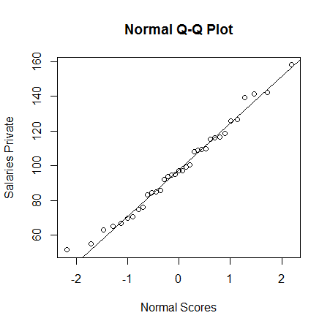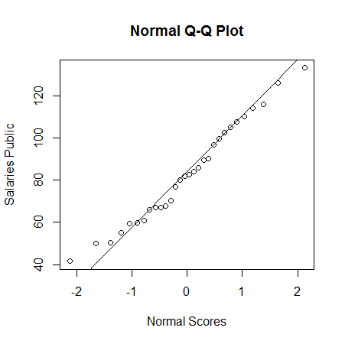

boxplot(private, public, ylab="Salaries", names=c("Private Salaries","Public Salaries"),main="Private and Public Salaries")

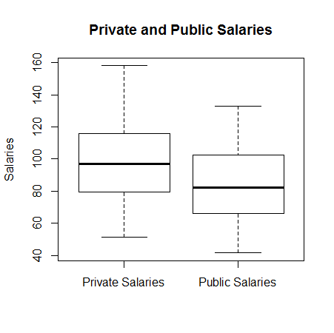

> t.test(private, public, alternative = c("two.sided"), mu = 0, paired = FALSE, var.equal = TRUE, conf.level = 0.95)

Two Sample t-test

data: private and public

**t = 2.3951**, df = 63, p-value = 0.0196

alternative hypothesis: true difference in means is not equal to 0

95 percent confidence interval:

2.487398 27.541173

sample estimates:

mean of x mean of y

98.19429 83.18000

**NOTE DIFFERENCE!**

> t.test(private, public, alternative = c("two.sided"), mu = 0, paired = FALSE, var.equal = F, conf.level = 0.95)

Welch Two Sample t-test

data: private and public

t = 2.412, df = 62.721, p-value = 0.0188

alternative hypothesis: true difference in means is not equal to 0

95 percent confidence interval:

2.573835 27.454736

sample estimates:

mean of x mean of y

98.19429 83.18000

> data2<-read.table("Seminar29Martie_b.txt", header=T)

> data2

score system

1 370 dynamic

2 360 dynamic

3 510 dynamic

4 445 dynamic

5 295 dynamic

6 315 dynamic

7 490 dynamic

8 345 dynamic

9 450 dynamic

10 505 dynamic

11 335 dynamic

12 280 dynamic

13 325 dynamic

14 500 dynamic

15 430 static

16 445 static

17 455 static

18 455 static

19 490 static

20 535 static

> attach(data2)

> table(factor(system))

dynamic static

14 6

> mean(score[1:14])

[1] 394.6429

> sd(score[1:14])

[1] 84.74996

> mean(score[15:20])

[1] 468.3333

> sd(score[15:20])

[1] 38.1663

> boxplot(score~system)

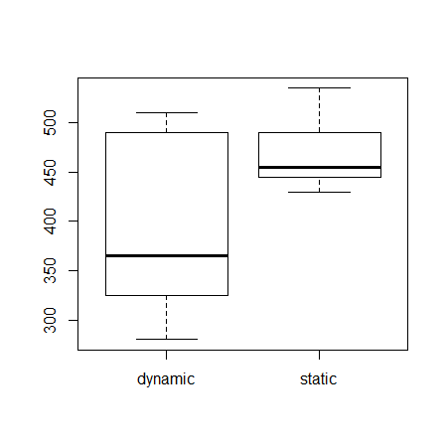

d=score[1:14]

s= score[15:20]

qqnorm(d)

qqline(d)

qqnorm(s)

qqline(s)

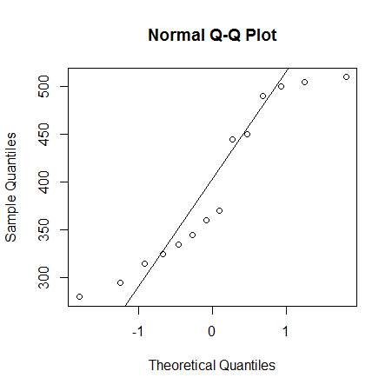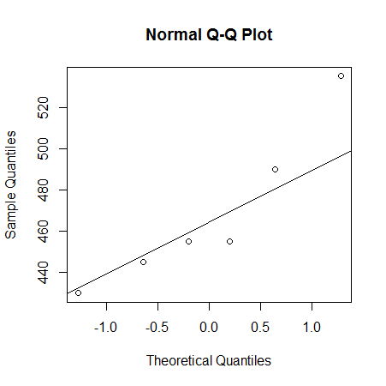

Dynamic Static

t.test(score~system, alternative = c("two.sided"), mu = 0, paired = FALSE, var.equal = F, conf.level = 0.95)

Welch Two Sample t-test

data: score by system

**t = -2.6804,** df = 17.832, p-value = 0.01536

alternative hypothesis: true difference in means is not equal to 0

95 percent confidence interval:

-131.48826 -15.89269

sample estimates:

mean in group dynamic mean in group static

394.6429 468.3333